Today’s Lecture Road Map
Dated: 7th May 2021
Services
https://developer.android.com/guide/components/services
A Service is a process running the background
- It does not have a UI
- A Service can communicate with the user through Toasts and the Status Bar
- Services can do basically anything in the background:
- Download/Upload Data
- Listen for data changes (location, etc.) or Intents
- Log information
Service’s lifecycle is a bit different from an Activity
- onCreate() – basically the same as Activity
- onStartCommand() – gets the service going
- onBind() – allows a Service to be a provider
- onDestroy() – basically the same as Activity
- stopSelf() – called by the Service to end it
- startService() and stopService() – Intent calls to start and stop a Service
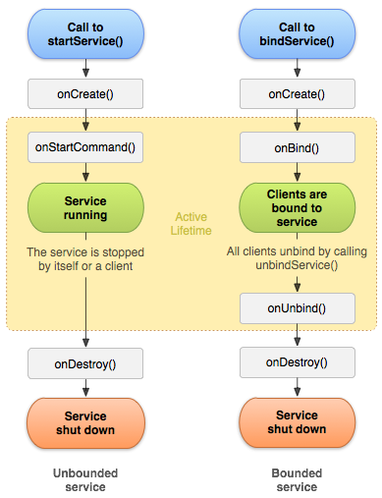
Starting and Stopping a Service
Works almost exactly the same as starting an Activity with an Intent. However, a Service will keep running after Activities close.
- You MUST manage your Services!
- Stopping them is necessary to not take up extra resources

Binding a Service
Consider a “normal” Service as doing a background activity for a single Activity. A Service that implements onBind() is one that is exposing some functionality for other Activities to utilize onBind() is called by other Activities to access the functionality
Services in the Foreground
Services can be set to run in the foreground, using startForeground(). It will start a Service that the system knows it can’t just kill if necessary. The Service should provide direct access to the user for interaction, such as the status bar
Example: a music player

Resource Crunch: No resources available, MAX utilization of resources OS will kill the processes
Services should not be killed if not necessary
Use Separate Threads: Services by default run on the same main thread
ANR [Application Not Responding] (long running tasks) -> fork a separate thread (child process)
Service “A” (running) -> Killed by OS due to Resource Crunch
Scenarios:
- Start from the beginning
- Resume

START STICKY: Auto restart with NULL INTENT
START NOT STICKY: No auto restart, but it can be started with an intent

Case 1: Service is explicitly Managed and Long Running (NO AUTO Restart)
Case 2: Service is NOT explicitly managed and it is self-stopping (triggered by an intent auto restart NOT required)
Case 3: Always restart and Restart from the state where it got killed (get intent)

Bound Services:
Case 1: WITHIN the application [Process A]: Local Binding : (IBinder)
Case 2: In between different Applications [Process A <-> Process B] (IPC) (AIDL and Messenger API)

https://developer.android.com/guide/components/aidl Read NOTE

Local Binding: IBinder
Activity A <- - - -- - -- - - -- - - -- - - -- -- Service
- Service is continuously generating Random Numbers
- Activity tries to bind to that Service and ask for the random number
- Service will assign a Random Number at that particular instant of time will be given to Activity UI
- Service will implement iBinder and return a iBinder
- Activity will use ServiceConnection API to connect to the service

